

VLSI

Lab 1

Jiayi Feng

2016200103020

2288941F

Instructor: Lianping Hou, Hadi Heidari

Date Performed: 2019/09/14

1.

I only figure out how to make schematic in the lab session, and I spend 3 day’s leisure time, to get familiar with the software and the layout, not to mention the time on lecture notes.

2.

NOR2 schematic:

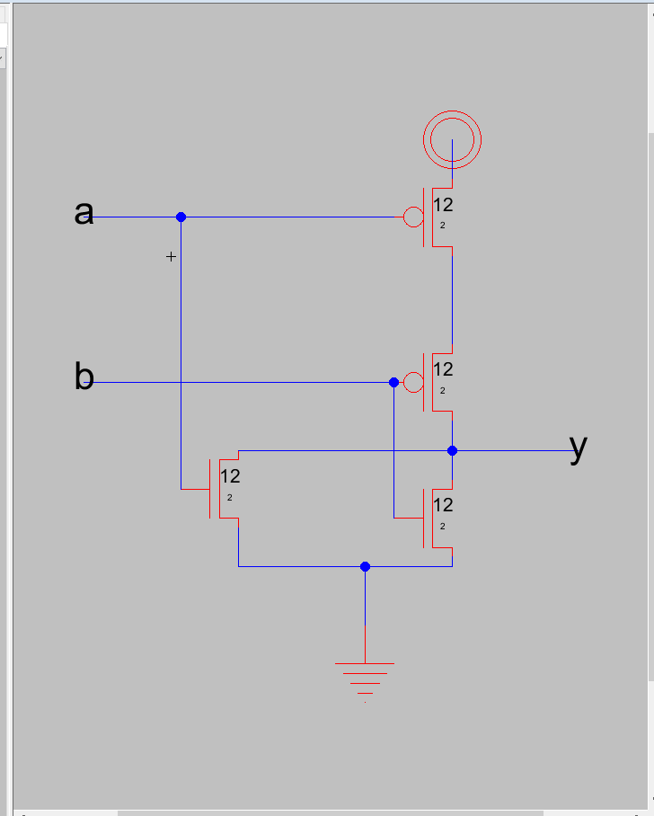

3.

NOR2 layout:

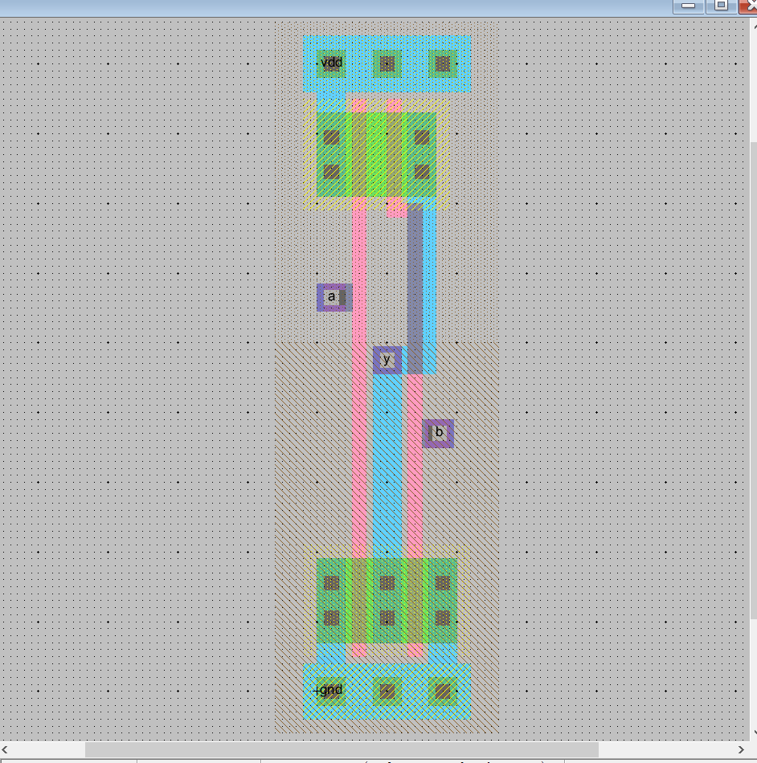

4.

OR2 schematic:

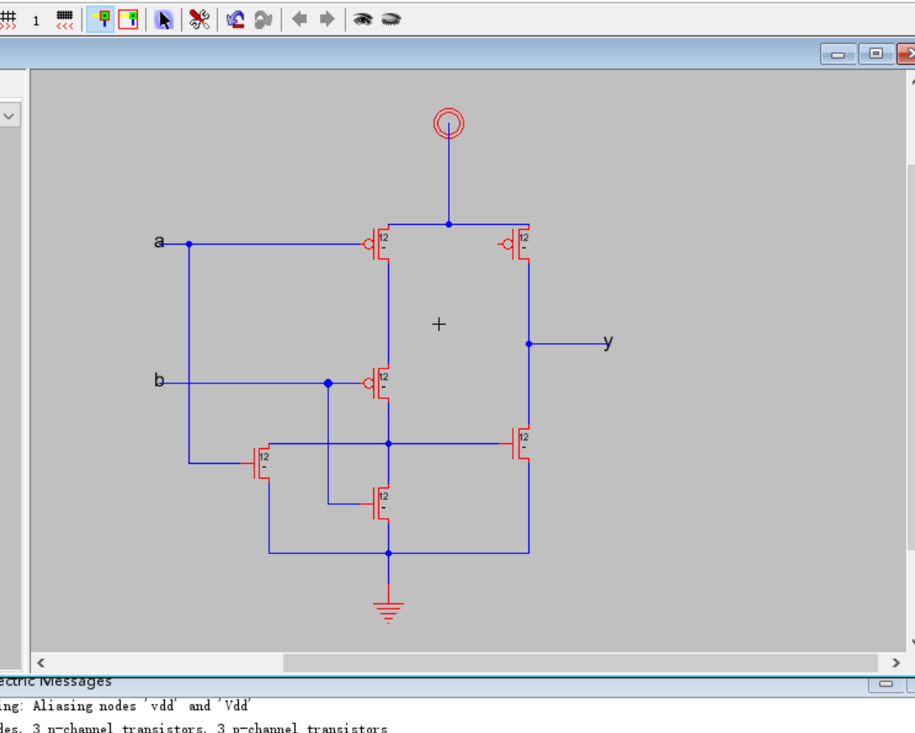

5.

OR2 layout:

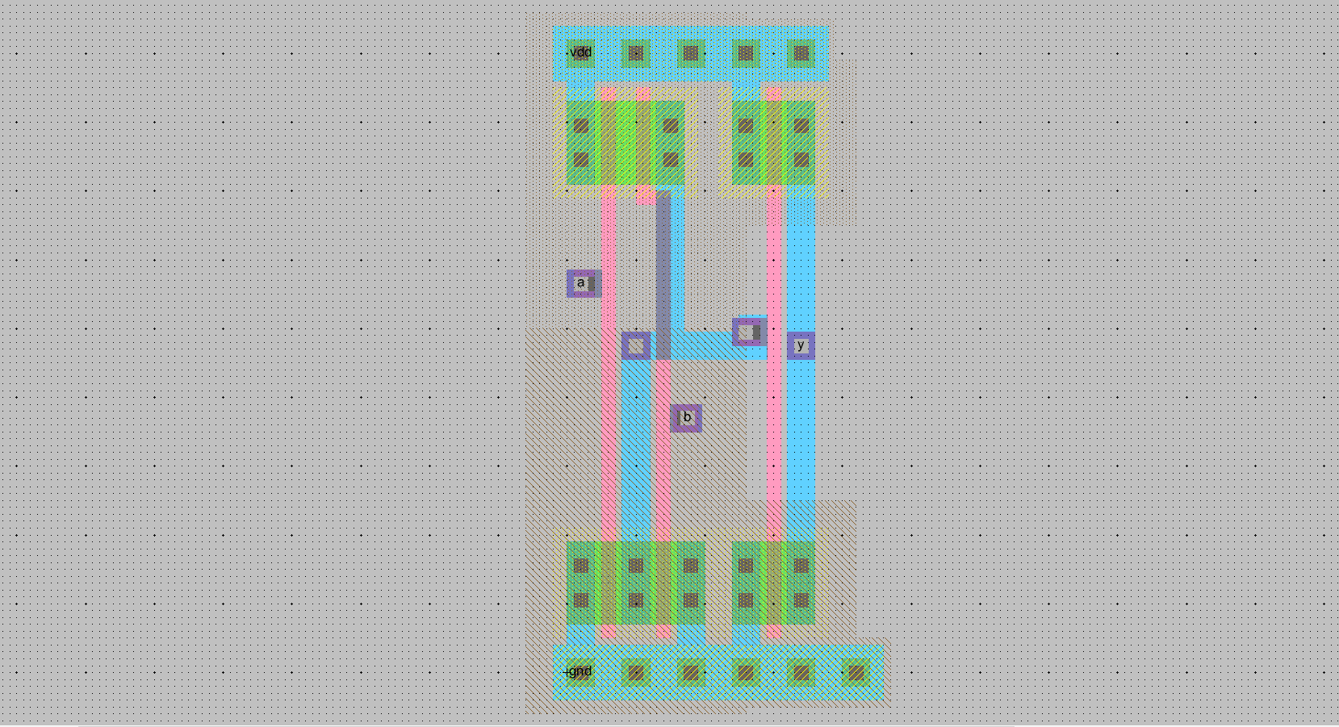

6.

